**Feature Testing:**

Email Notification Test



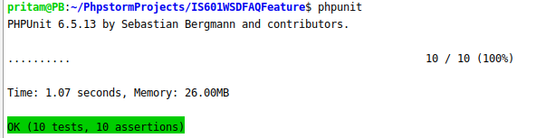

Question Test

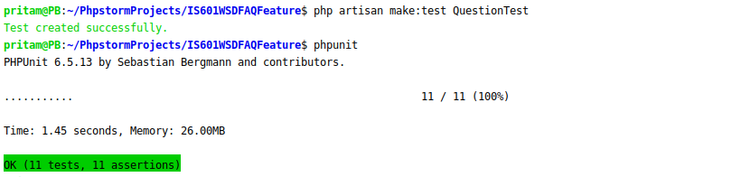

Answer Test



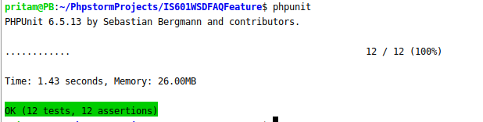

**Dusk testing:**

For Profile



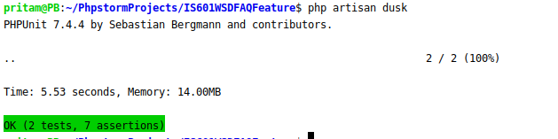

For Login

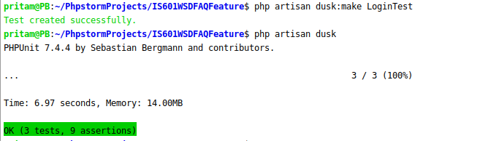

For Register

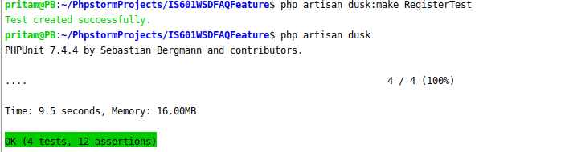

For Create Question



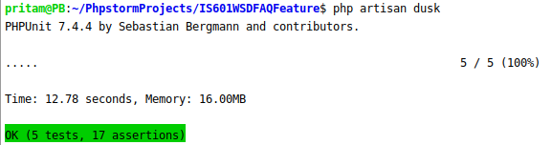

For Edit Question

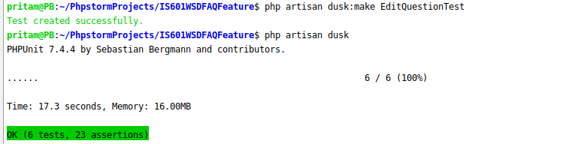

For Create Answer

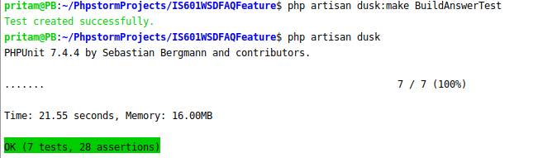

For Edit Answer

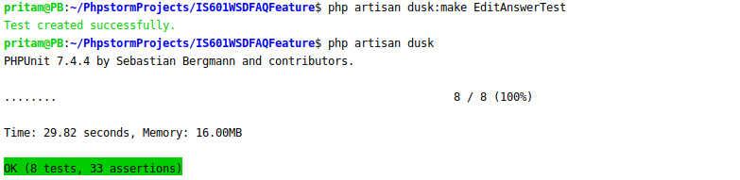

For Delete Question



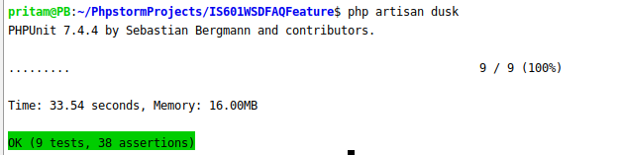

For Delete Answer



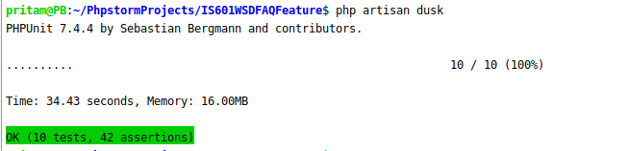

**After changes and bugs fixing**

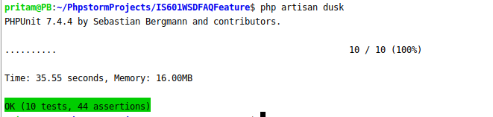

**Unit testing**

For Question Notification



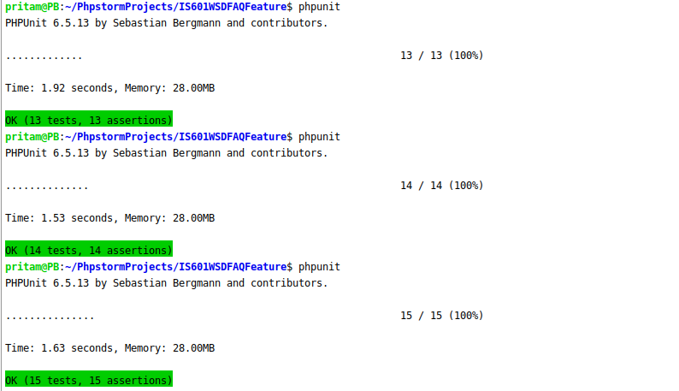

For Answer Notification

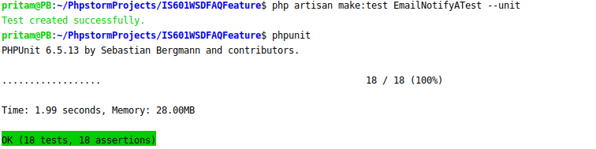

For Question and Answer Mail

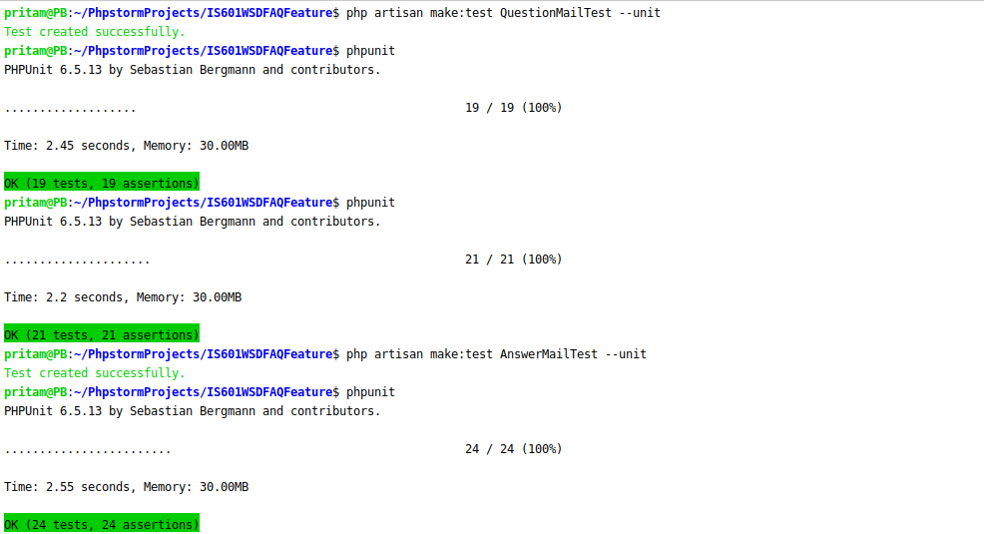

For Login, Register and Notification Page Response

